CLIENT | : | OBEROI REALTIY
SITE | : | ?, MUMBAI
LOCATION | : | MUMBAI, MHARASHTRA
NO. | : | -
DOCUMENT NO. | : | DBR-R00

R00 | 28-06-2025 | Design report | R.H.B | H.A.B | H.A.B
Rev No. | Date | Description | Prepared By | Checked By | Approved By

TABLE OF CONTENTS

Sr. No | Contents | Page No.
1 | Design Philosophy | 3
2 | Design Codes and Standards | 4
3 | Material Specifications Construction | 4
4 | Load Calculations | 5
4.1 | Dead Load | 5
4.2 | Live Load | 6
4.3 | Wind Load Calculations | 7
5 | Deflection Check | 8
6 | Primary Loads and Load Combinations | 8

- Design Philosophy
This document pertains to structural design of retractable roof, Mumbai, Maharashtra at 215m from ground level. The overall size of the frame is 4.638x 3.4 x 0.7m high. The main sliding frame is of mild steel material. The wind load is worked out from IS 875 Part III. The various DL and LL acting at different points on frame are transferred to the nearest columns through the grid of beams.
The complete frame is modelled as 3D frame and analysed/designed for worst combination of loads through STAAD.pro. Input and output files are enclosed which are self-explanatory. From the STAAD output, the support reactions for various primary load cases are tabulated and the base plate, shear keys and foundation bolts are designed accordingly. Foundation design shall be done using appropriate load combinations for reactions given in this document.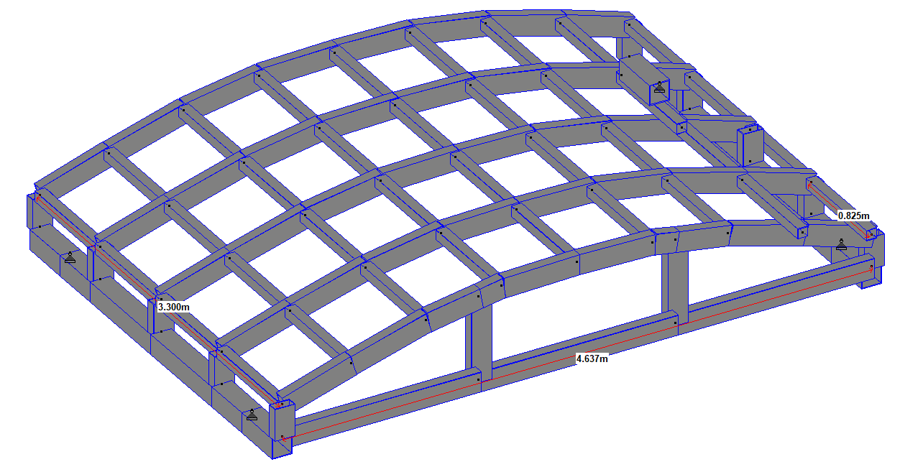

- DESIGN CODES AND STANDARDS
Code / Standard | Applicability | Remark
IS800-2007 | Design of steel structures | --
IS 875-Part III | For wind load calculation | --
IS 875-Part I | For dead load calculation | --

- MATERIAL SPECIFICATION FOR CONSTRUCTION
Sr.no | Material | Specification | Minimum Strength
1 | Mild steel | IS2062 | Fy = 210 N/mm²

- LOAD CALCULATIONS
  - DEAD LOAD
SELFWEIGHT FACTOR = 1
Dead load for glass/sheet assumed = 5 Kg/m² i.e. 0.05 kN/m²
Member c/c spacing of 0.83m = 0.83x0.05 = 0.0415kN/m
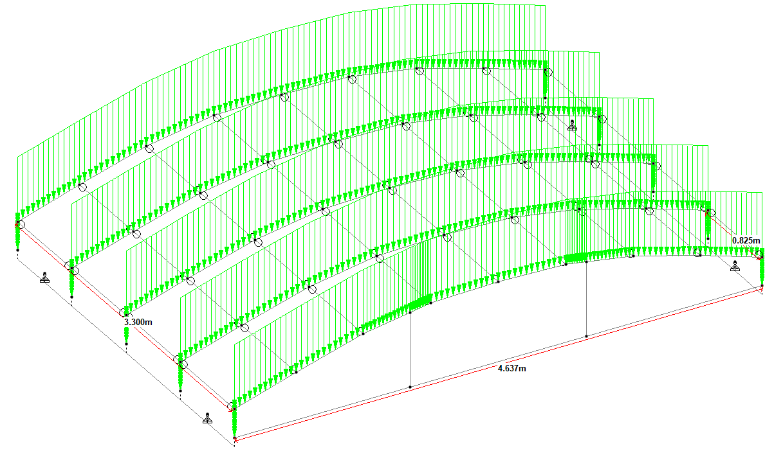
  - LIVE LOAD
Live load assumed = 0.75 kN/m²
Member c/c spacing of 0.83m = 0.83x0.75 = 0.6225kN/m
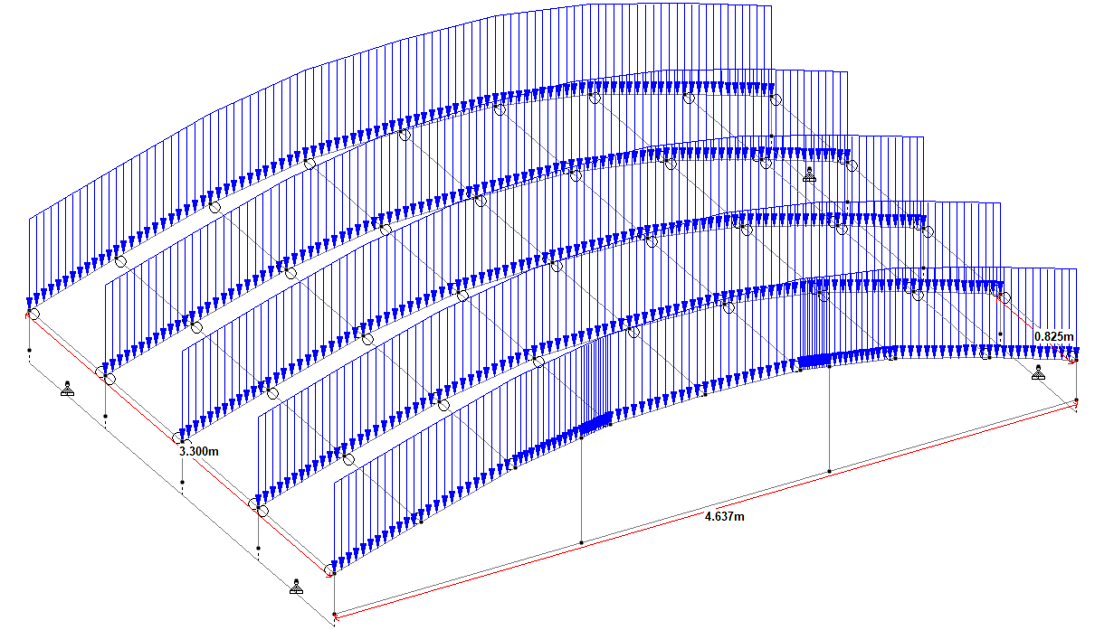
  - WIND LOAD
For wind load calculation, following IS code is referred: - “IS 875 Part III”

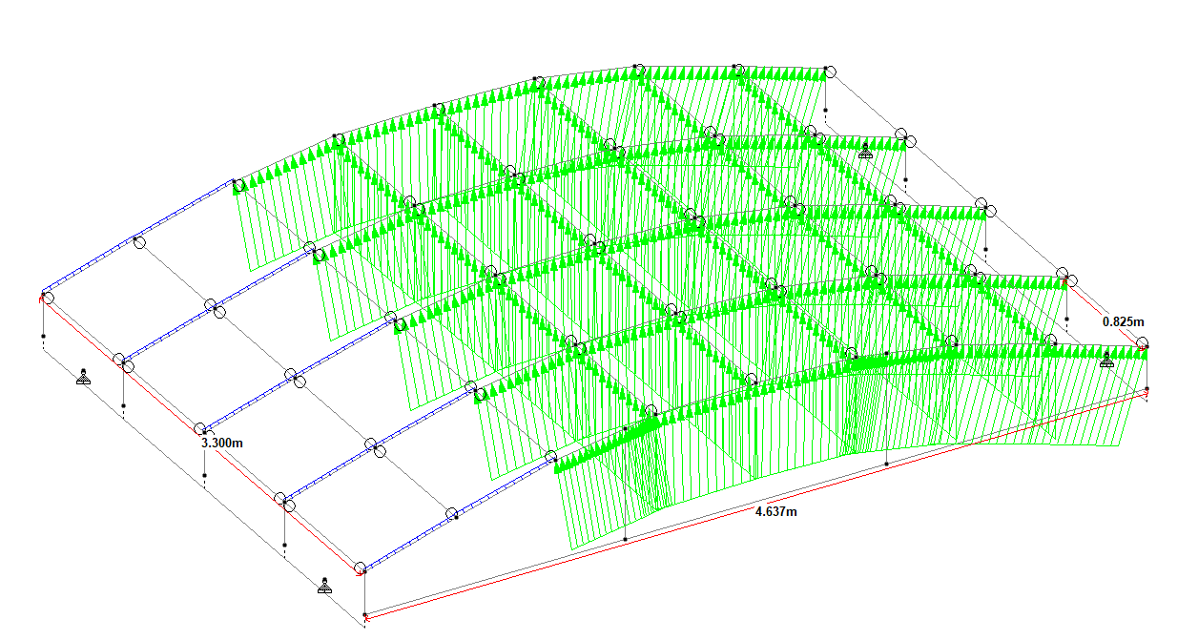

- Deflection check at building top in Z direction
Refer node no. –30 of staad file for load combination 202
Max. Deflection in Y dir. = 1.94 mm < L/250 = (IS 800-2007 table 6)
.... Hence ok.

- PRIMARY LOADS & LOAD COMBINATIONS
  - PRIMARY LOADS
Load 1 Dead Load (DL)
Load 2 Live Load (LL)
Load 3 Wind Load Pressure (WLX)
Load 4 Wind Load Suction (WLZ)
Load 5 Wind Load Suction (WL-X)
Load 6 Wind Load Suction (WL-Z)

  - LOAD COMBINATIONS
Load Combination for strength:-
1.5 DL + 1.5 LL
1.5 DL + 1.5 WLX
1.5 DL + 1.5 WLZ
1.5 DL + 1.5 WL-X
1.5 DL + 1.5 WL-Z

Load Combination for serviceability:-
DL + LL
DL + WLX
DL + WLZ
DL + WL-X
DL + WL-Z
DL + 0.8 WLX
DL + 0.8 WLZ
DL + 0.8 WL-X
DL + 0.8 WL-Z

